

Mohd. Razia Alangir Banu
MALLAVARPU BALA PRANITHA
2520030051
CSE
CO-3

Case Study Topic: SmartGrid – Infrastructure Design & Network Optimization System

Work Done Summary:
The SmartGrid system was designed by modeling infrastructure as a weighted undirected graph, where nodes represent locations and edges represent connections with associated costs. BFS was implemented to traverse the network level by level and identify all reachable nodes, while DFS was used to explore deep paths and verify connectivity between different regions. To optimize infrastructure cost, Kruskal’s algorithm was applied by sorting all edges and selecting the minimum weighted edges using a union-find approach to form the Minimum Spanning Tree. Additionally, Prim’s algorithm was used to grow the MST from a starting node using a greedy approach with minimum edge selection. These implementations together ensured efficient network traversal, connectivity analysis
and cost-optimized infrastructure design.

Implementation Details:
- Graph is represented using an adjacency list with weighted edges.
- BFS is used to explore all nodes level-by-level using a queue.
- DFS is implemented using recursion/stack for deep traversal and connectivity analysis.
- Kruskal’s algorithm sorts all edges and builds MST using Union-Find (Disjoint Set).
- Prim’s algorithm expands MST using a priority queue (min-heap) for greedy selection.
- Final MST ensures minimum cost infrastructure design with O(E log E) or O(E log V) complexity.

Output:
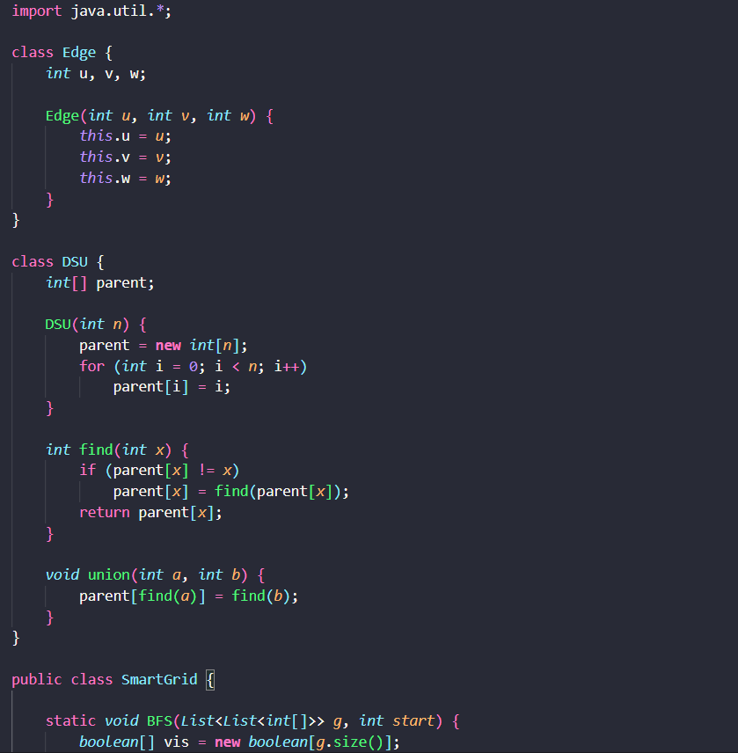

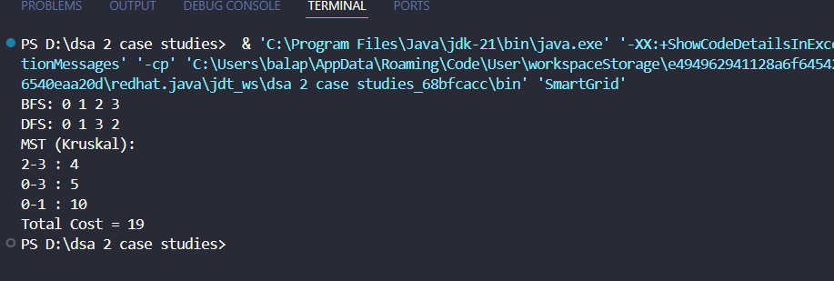

SmartGrid demonstrates how graph algorithms optimize real-world infrastructure systems. BFS and DFS ensure efficient traversal and connectivity analysis, while Kruskal’s and Prim’s algorithms construct a Minimum Spanning Tree to minimize total construction cost. This combination enables optimal design of networks such as power grids, transportation systems, and communication networks with minimal cost and maximum efficiency.

Github Link: https://github.com/balapranithamallavarapu-cmyk/DSA-II-Case-Studies

